**How It Works: Tutor.com Classroom**

Connecting with expert tutors for on-demand, 1:1 help

The expert tutors at Tutor.com can help you work through a tough homework problem, improve your writing skills, study for a test, review a difficult concept, and so much more!



**Step 1: Get started**

1. Go to: [Enter program URL or access

instructions.]

1. Click on **Tutor.com**.
2. Create or sign in to your free Tutor.com account.

4. Click on **Connect with a Tutor**.

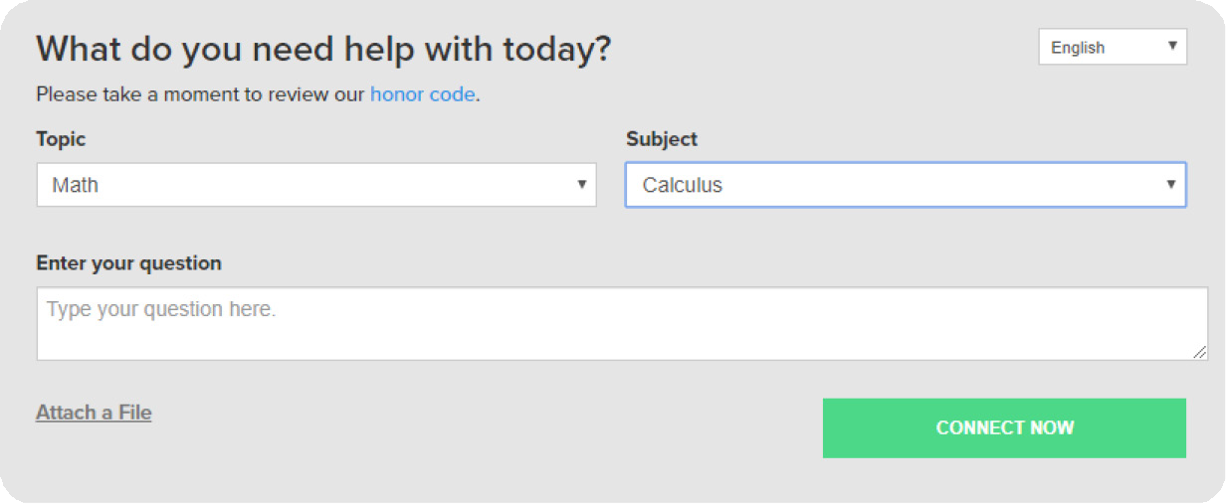

**Step 2: Get the right tutor**

Fill in the quick pre-session questionnaire. Using this information, we will match you with the first available tutor best qualified to assist you.

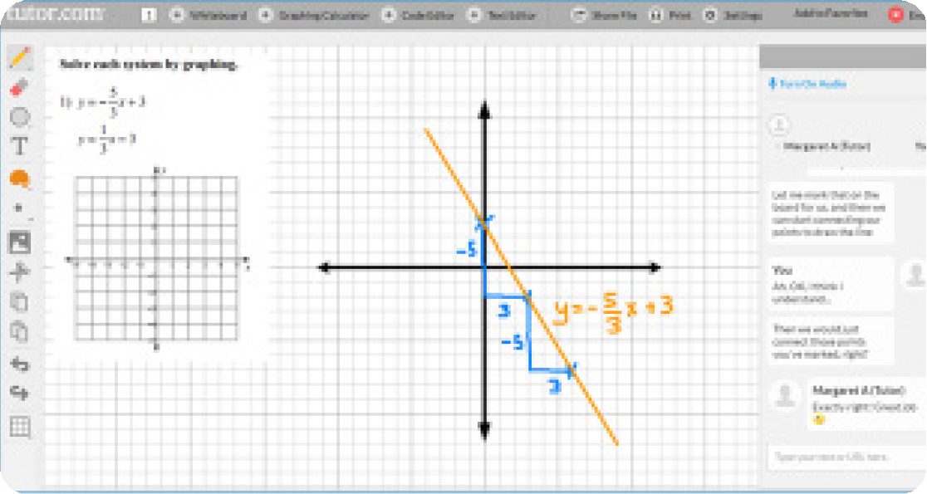

**Step 3: Communicate**

Use your chat box or an audio connection to instant message or speak with your tutor in the online classroom. You and the tutor may also use the interactive whiteboard to share work and ideas. *All activity in the classroom is recorded for review and quality control.*

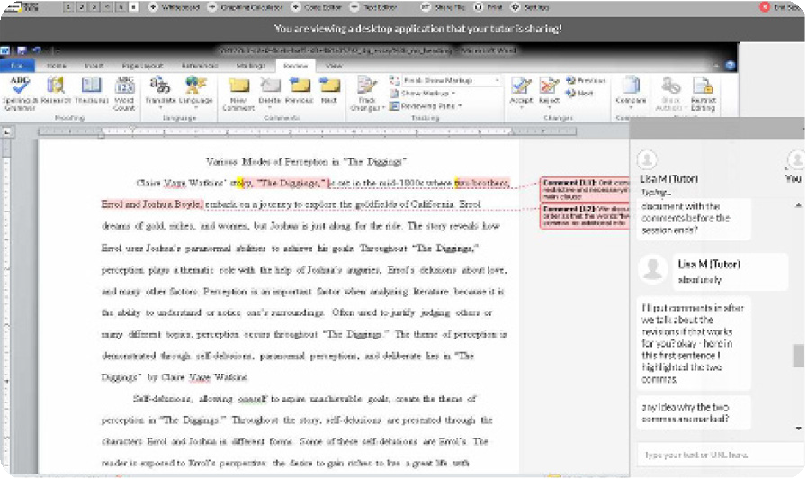

**Step 4: Share a file**

You can share many types of files with your tutor in the classroom. Upload an essay, your lab report, a PowerPoint presentation, and more. You and your tutor will be able to view the file together in the classroom.

**MORE**

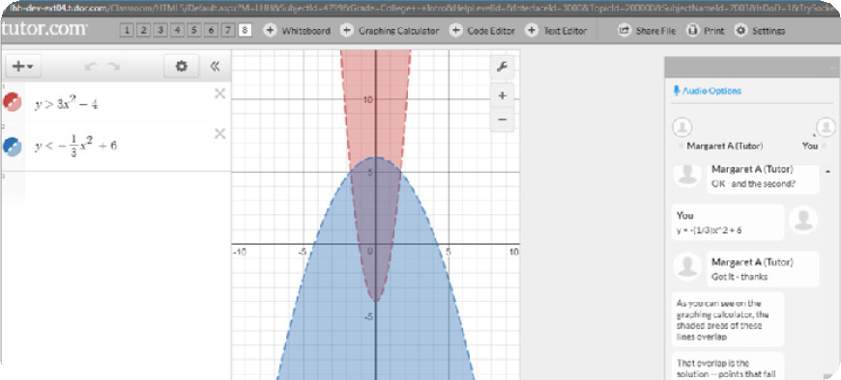

**Step 5: Use special tools**

The classroom includes a graphing calculator, text editor, and code editor that you can use when working on subject material that may require these special tools. Open them by using the buttons above the whiteboard.

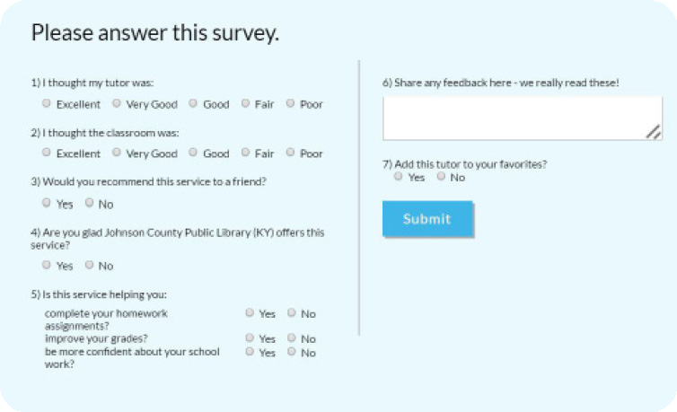

**Step 6: Rate and review your session**

After each session, be sure to let us know how we did! Complete the survey and share your comments. Then you’ll have the option to play a video of your session and email or print the chat log and whiteboards.

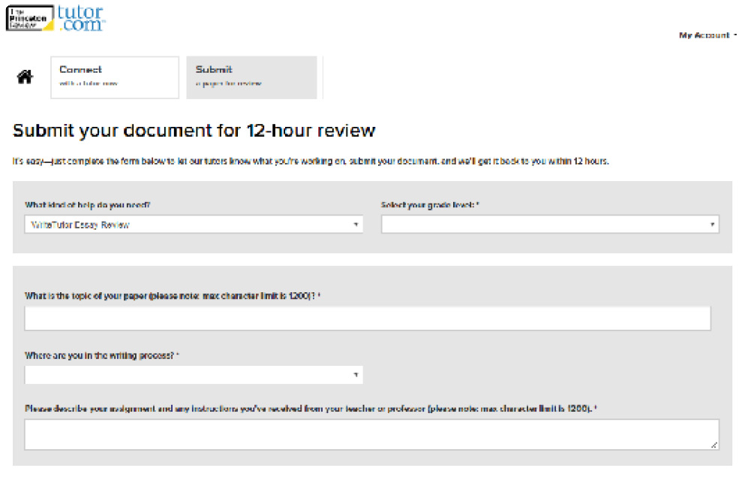

**Step 7: Submit your paper**

Our **Drop-Off Review** service allows you to get expert help from a tutor without having to connect for a real-time session. Upload your writing assignment and get detailed feedback and explanations within 12 hours. Retrieve your tutor’s completed review under **My Sessions**.

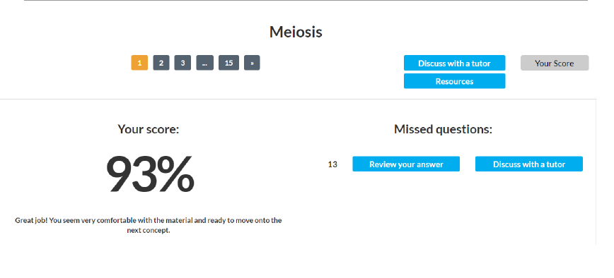

**Step 8: Practice for a test**

Use our practice quizzes to assess your level of knowledge and practice for upcoming tests or quizzes in math, science, and English. Take a quiz, review your results, and

connect with a tutor to discuss any missed questions.

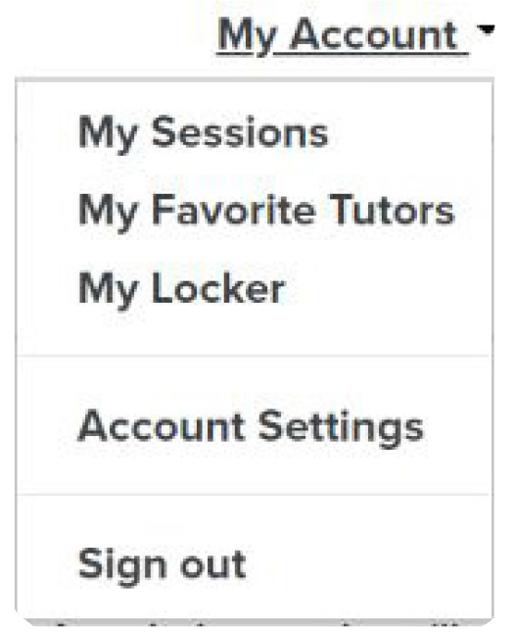

**Step 9: Use *My Account***

* Review previous sessions and retrieve drop-off reviews from **My Sessions**. Be sure to tag your favorite tutors when reviewing your sessions.
* Reconnect with your favorite tutors or see when they are next scheduled from the **My Favorite Tutors** section.
* Access files you have saved or those you have shared in session with your tutors from **My Locker**.

The Princeton Review is not affiliated with Princeton University.